A very warm welcome
Our speaker today is Chris Fishlock
Our passage is Haggai 2:1-9

Notices

1. New? If you’re here for the first time and would like more information about the London Bridge Talks, including our weekly email, please fill in a contact card or visit: www.londonbridgetalks.org/new.

2. Partnership. A weekly opportunity to discuss with others how what we’re hearing applies to life in the City. Email tom.wright@snca.co.uk for details.

Talk recordings & info | www.londonbridgetalks.org
God’s Building Project (2) Haggai 2:1-9 Page 791
Introduction

- Source of discouragement – a rather pathetic looking temple (v3)

Looking back to the glory days of the past

Looking in at the apparent worthlessness of the present

- Solution to discouragement – a Glorious God who promises (v4-9)

Look back to what God has done

Look forward to what God will do

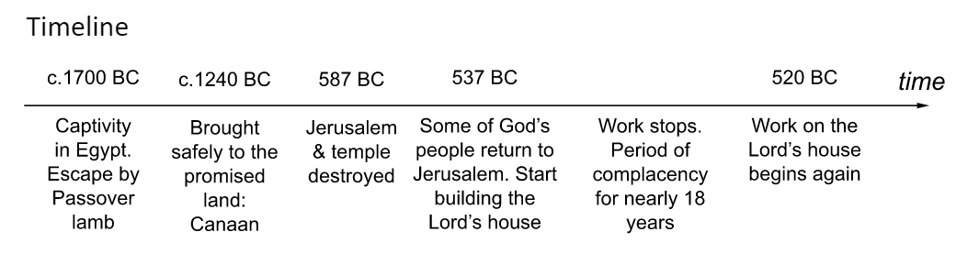
Questions:
- In what ways are we tempted to be discouraged?
- What are the solutions to discouragement that Haggai gives the people?
- How can we do this effectively today?

A very warm welcome
Our speaker today is Chris Fishlock
Our passage is Haggai 2:1-9

Notices

1. New? If you’re here for the first time and would like more information about the London Bridge Talks, including our weekly email, please fill in a contact card or visit: www.londonbridgetalks.org/new.

2. Partnership. A weekly opportunity to discuss with others how what we’re hearing applies to life in the City. Email tom.wright@snca.co.uk for details.

Talk recordings & info | www.londonbridgetalks.org
God’s Building Project (2) Haggai 2:1-9 Page 791
Introduction

- Source of discouragement – a rather pathetic looking temple (v3)

Looking back to the glory days of the past

Looking in at the apparent worthlessness of the present

- Solution to discouragement – a Glorious God who promises (v4-9)

Look back to what God has done

Look forward to what God will do

Questions:
- In what ways are we tempted to be discouraged?
- What are the solutions to discouragement that Haggai gives the people?
- How can we do this effectively today?

